**COMSATS University, Islamabad**

**Assignment # 1**

**Author**

***Muhammad Mujtaba SP22-BSE-036 2A***

**Course**

***Calculus ()***

**Instructor**

***Sir Khurram Shahzad***

**Date**

***Sep 26, 2022***

**ONTO Function**

In onto function every element in co-domain should have a pre-image in domain. Or simply, range should be equal to co-domain. This type of function is also called **surjective function**.

* **Example 1**

Suppose y = f(x) = 2x

X = {2, 4, 6} f: R -> R

Y = {4, 8, 12} R = (2, 4), (4, 8), (6, 12)

|  |  |  |
| --- | --- | --- |
| x | y | (x, y) |
| 2 | 2(2)=4 | (2,4) |
| 4 | 2(4)=6 | (4,8) |
| 6 | 2(6)=12 | (6,12) |

X Y

2 4

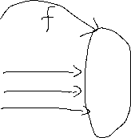

4 8 Range = co-domain

6->domain 12->co-domain

Every element in co-domain also have a pre-image in domain so it is surjective (onto) function.

* **Example 2**

Y = f(x) = x2 X = {0,3,4,9} y = {0,9,16,81,100}

F: R->R R=(0,0,),(3,9),(4,16),(9,81)

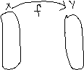

|  |  |  |
| --- | --- | --- |
| x | y | (x, y) |
| 0 | 0 | (0,0) |
| 3 | 9 | (3,9) |
| 4 | 16 | (4,16) |
| 9 | 81 | (9,81) |
|  | 100 |  |

This function is injective as well as into and one-to-one.

**INTO Function**

An into function is a type of function in which atleast one element of co-domain doesn’t have any pre-image in domain.

* **Example 1**

Suppose y = f(x) = 2x + 1

X={1,2,3} y={3,5,7,8} f: R -> R

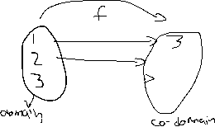

|  |  |  |
| --- | --- | --- |
| x | y | (x, y) |
| 1 | 2(1)+1=3 | (1,3) |
| 2 | 2(2)+1=5 | (2,5) |
| 3 | 2(3)+1=7 | (3,7) |

R=(1,3),(2,5),(3,7)

As 8 doesn’t have any pre-image in domain, so this type of function is called as into function.

**Bijective Function**

A function which is both surjective and injective is termed as bijective function, e.g. every element in co-domain should have a image in domain and every element of co-domain is the image of at most one element of its domain.

* **Examples**

1. **Injective:**

X={2,4,6,8} y={a,b,c,d,e} R={(2,a),(4,b),(6,c),(8,d)}

X y

2 a

4 b



6 c



8 d

e

1. **Surgective:**

X={2,4,6,8} y={a,b,c} R={(2,a),(4,b),(6,c),(8,c)}

X y

2 a

4 b

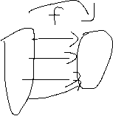

6 c

8

1. **Bijective:**

X={a,b,c,d} y={1,2,3,4} R={(a,1),(b,2),(c,3),(d,4)}

X y

A 1

B 2

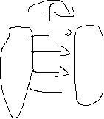

C 3

D 4

